**TITLE: Invasive ungulates are major drivers of forest composition in avian-free novel ecosystems**

**AUTHORS:** Ann Marie Gawel, University of Guam, U.S. Fish and Wildlife Service

Email: [anngawel@gmail.com](mailto:anngawel@gmail.com)

Haldre S. Rogers, Rice University

Email: [hsr@rice.edu](mailto:hsr@rice.edu)

Ross H. Miller, University of Guam

Email: [rhmiller@uguam.uog.edu](mailto:rhmiller@uguam.uog.edu)

Alexander M. Kerr, University of Guam

Email: [alexander.kerr@aya.yale.edu](mailto:alexander.kerr@aya.yale.edu)

**KEYWORDS: *ungulates, invasive species, herbivory, seed dispersal, limestone karst forest, Mariana Islands***

**Abstract**

Conservation has long focused on preserving or restoring pristine ecosystems. However, understanding and managing novel ecosystems has grown in importance as these systems outnumber pristine ecosystems worldwide. We examined species interactions in the novel ecosystems of the island of Guam, where native vertebrate frugivores are functionally absent, and Rota, a neighboring island that still retains native frugivore populations. This study focused on the roles of long-established ungulates – Philippine deer (*Rusa mariannae*) and feral pigs (*Sus scrofa*) – on seedling survival, seed dispersal, and plant community structure in limestone karst forests. Ungulates reduced survival of 4 out of 6 species of seedlings in unfenced plots compared to fenced plots on both islands, although the effect of deer could not be isolated from that of pigs. However, native and non-native seedling and vine abundance showed strong negative loglinear correlations (R2 ≥ 0.65) to deer, and not pig, abundance on the island of Guam only; a diverse seedling community is only found under very low deer abundances. Although pig abundance was not strongly correlated to plant community characteristics, germination experiments of seeds found in scat revealed that pigs disperse both native and exotic species, which is likely to have ? effects on forest composition, whereas deer disperse very few viable seeds. In the novel forest ecosystems of Guam, non-native ungulates shape forest composition – deer have a strongly negative effect on diversity through herbivory, whereas pigs may provide important seed dispersal services in forests that lack all native vertebrate seed dispersers. Non-native species may fill missing ecological roles in novel ecosystems, and in doing so, complicate management decisions.

**Introduction**

The extent of human influence is so pervasive that the earth today is comprised mostly of novel ecosystems (Seastedt et al. 2008) -- systems with species compositions and relative abundances that have not been previously observed (Hobbs et al. 2009). Species introductions create and maintain novel ecosystems both by adding new species and by removing native species (Seastedt et al. 2008). Novel ecosystems typically still harbor many native species, however, effective management of these systems is challenging due to the potentially novel ecological roles of the remnant native and introduced species that comprise them.

Most conservation goals focus on restoring native species to historical abundances, and conservation efforts that have focused on removing invasive species and reintroducing native species have yielded many positive results. However, removing invasive species could have negative consequences if these species play important ecological roles otherwise missing from the novel system (Zavaleta et al. 2001). Likewise, reintroducing reduced or extirpated native species may prove unsuccessful or detrimental if persistent threats and current conditions are poorly understood (Hobbs et al. 2011, Godefroid et al. 2011). Restoring a functioning ecosystem rather than the original complement of species may be more feasible for highly degraded ecosystems (Hobbs et al. 2011).

Although the negative impacts of introduced species are extensive, some may also play beneficial roles (Davis et al. 2011, Schlaepfler et al. 2011). Introduced species can be good candidates for restoring severely degraded habitats (Ewel and Putz 2004). For example, in Puerto Rico, planting non-native trees in abandoned pastures where the native plants would not have originally colonized facilitated the return of native plant communities (Lugo 1997). Some introduced species may provide desirable ecological functions such as seed dispersal or food sources for native species (Goodenough 2010). Introduced Japanese white-eyes (*Zosterops japonica*) in Hawaii are seed dispersers for native plants that previously relied on now extinct or rare native birds (Foster and Robinson 2007). Finally, invasive species may slow or reverse negative ecological effects from other anthropogenic impacts. Cascading ecological effects from overfishing in Cape Cod salt marshes are being reversed by green crabs (*Carcinas maenas*), which are normally considered a harmful invasive (Bartness and Coverdale 2013).

Deer and pigs have been introduced across the globe throughout history, and their negative effects on ecosystems have been well documented, even within their native ranges (Ickes 2001, De Garine-Wichatitsky 2003, Nogueira-Filho et al. 2009, Takatsuki 2009). Deer alter forest structure by browsing on seedlings and saplings, suppressing forest regeneration (Takatsuki 2009). In North America, decreased seedling height and abundance were observed across multiple hardwood species with increasing abundance of white-tailed deer (*Odocoileus virginianus*) (Horsley *et al.* 2003). Pigs are known to affect regeneration and recruitment in a number of forest systems. For example, feral pigs have a pronounced effect on regeneration in lowland forests of Malaysia, by direct predation on seeds and by soil-rooting (Ickes *et al.* 2001). Rooting kills or physically damages seedlings and can alter soil properties (Singer *et al.* 1984, Ickes *et al.* 2001). Pigs are seen as a major threat to native biodiversity in Hawaii, where exclosure studies have shown marked increases in forest recruitment and seedling abundance (Loh and Tunison 1999, Weller *et al.* 2010) when pigs were eliminated from the areas.

The islands of Guam and Rota in the Mariana Archipelago, as with many islands around the world, have had a long history of species introductions (Fritts and Rodda 1998) making them prime examples of novel ecosystems with unique management challenges. The most famous invasive species in Guam is the brown treesnake (*Boiga irregularis*), which was unintentionally introduced on military cargo at the end of World War II (Rodda 1992). It is responsible for the extinction of most of Guam’s native birds between 1945 and 1985 (Savidge 1987, Wiles 2003), functionally leaving the island without native vertebrate nectarivores, frugivores, or insectivores (Fritz and Rodda 1998). The nearby island of Rota has very similar flora and fauna to Guam, lacks the brown treesnake, and has retained limestone karst forests that are relatively more pristine than those on Guam (Falanruw et al. 1989). Deer and pigs have been established for centuries on both islands (Safford 1905, Conry 1989, Wiles et al. 1999). Philippine deer (*Rusa* *mariannae*) density in Guam has been correlated with reduced seedling recruitment in some species of native trees (Wheeler 1979, Schreiner 1997). Similar to their effects in other islands, feral pigs (*Sus scrofa*) on Guam alter habitats by rooting and wallowing (Conry 1989), which can disrupt forest regeneration. However, these impacts are occurring within unique novel rather than pristine ecosystems, therefore a more thorough examination of the role of each species within the larger ecological context is needed to make appropriate management decisions.

We investigate the ecological role of invasive ungulates in two novel ecosystems. We examine the impact of feral pigs and deer on seedling survival, seed dispersal, and overall plant community composition. We contrast their role in the bird-free forests of Guam to that in the nearby forests of Rota which still maintain avian populations.

**Methods**

*Study Area*

Guam (13.45° N, 144.78° E; 540 km2) is the largest and southernmost island of the Mariana Island Archipelago in the Western Pacific. Rota (14.15° N, 145.21° E; 85 km2) is located 76 km north of Guam and has less than 2% of the population of Guam. Both islands have large areas of native limestone karst forest with similar species compositions. These islands contain a variety of habitat types, but karst forests were chosen as the focus of this study because they contain a larger variety of native and endemic tree species relative to other habitats, such as savannah or ravine forest (Fosberg 1960, Raulerson and Rinehart 1991).

*Effect of ungulates on seedling survival*

To assess ungulate effects on seedling mortality, we set up paired plots in karst forest sites in northern Guam and in Rota. Eight sites were selected in Guam and seven sites in Rota. At each site, we erected a 1.8-m tall chicken-wire fence around one plot, and left the adjacent plot unfenced, allowing ungulate access. The fenced and unfenced plots were placed so that individual pairs had similar canopy cover, rockiness, and forest structure. Each seedling plot covered an area of about 3.5 m x 5.5 m.

We selected six species for this experiment encompassing a variety of common native and introduced trees found in forests of the Mariana Islands: *Carica papaya*, *Morinda citrifolia*, *Neisosperma oppositifolia*, *Aglaia mariannensis*, *Premna obtusifolia*, and *Psychotria mariannensis*. For each species we collected seeds from at least five trees and at least four different sites to minimize maternal effects and effects of local adaptation. The date of seed collection and subsequent out-planting was staggered by species due primarily to differences in fruiting phenology. After seeds were collected, fleshy fruit was removed, and they were planted in a mixture of 50% perlite and 50% peat moss, and fertilized using Osmocote®. All seeds were planted on the island from which they were collected. The seed trays were placed under 60% shadecloth at a nursery in Guam and at a nursery in Rota, and allowed to grow in these conditions until they had fully rooted and grown their first true leaves. At this point, the seedlings were transported to the exclosure sites for out-planting.

Seedlings of each species were out-planted in the control and treatment areas at each site on the same day. Seedlings were placed at least 0.3 m apart from each other, and at least 0.5 m away from the fences in fenced treatments. Fourteen seedlings of each species were planted in each treatment at each site, except for *N. oppositifolia*, which had only seven seedlings planted per treatment on Guam and 9 seedlings per treatment on Rota. In addition, 11 seedlings per plot of *Carica papaya* were planted on Rota. The seedlings planted during drier months (*C. papaya, M. citrifolia,* and *N. oppositifolia*) were watered regularly during the first few weeks following transplanting to ensure they successfully established. After transplanting, seedlings were monitored monthly for survival until July 2011 (15 months after the first species was transplanted and four months after the last).

*Germination from fecal samples*

We collected feces from *R. marianna* and *S. scrofa* from limestone karst forest sites to determine if either ungulate dispersed viable seeds via endozoochory. We collected throughout the year, through both rainy and dry seasons from four different sites in northern Guam. Fecal samples were layered on top of a 50% perlite and 50% peat moss soil mix in germination trays. The trays were kept outdoors at a nursery under shadecloth. *R. marianna* pellets were mixed in at the surface, and *S. scrofa* scat samples were broken up and mixed at the surface. Trays were watered regularly before and after seedlings emerged from feces. Seedlings were then identified and counted. Because the nursery was open air, species that were known to be wind-dispersed and that germinated in most of the other seedling trays at the nursery were not counted.

*Vegetation transects and scat counts*

We conducted vegetation surveys to gather community composition data about karst forest sites across Guam and Rota. We surveyed vegetation at each site using 100-m by 1-m transects. At sites with exclosures, transects extended from opposite corners of the exclosure. At sites without exclosures, transects were placed end to end. All plants within the belt transects were identified and recorded, seedlings were identified and counted, and plants were categorized as vines, trees, ferns, or herbs.

To estimate relative ungulate abundance between sites, fecal groups from *S. scrofa* and *R. marianna* were counted along the vegetation transects as well as in a 2-m wide square-shaped belt transect that encompassed the vegetation transects. Although they do not give exact population abundance, scat counts can be used as an index to compare abundance of ungulates between sites (Engeman et al. 2013). Each transect covered an area of about 800 m2. We used scat as an indicator of ungulateabundance since other sign such as animal tracks are rarely visible in karst forest terrain and the detectability of other sign such as trails and grazing varies widely even in similar habitats (Schreiner 1997).

*Statistical analyses*

Seedling survival was compared for each planted species between fenced and unfenced plots, using generalized linear mixed effects models (lme4 package) and R statistical software (R Development Core Team 2013). Fencing, and island were considered fixed effects, while site was considered a random effect. We analyzed each species separately. Factors were sequentially removed, and were considered to have a significant effect on seedling survival if they reduced Akaike Information Criterion, corrected for smaller sample sizes (AICc), scores by more than 2 (Burnham and Anderson 2004) when included in a linear model.

To determine if pigs exhibited selectivity for either native or exotic species, we collected scat from multiple sites on Guam and compared the abundance of species that germinated from scat to their abundances in vegetation surveys from those same sites. t We calculated the Manly Selectivity Index (Manly et al*.* 1993) for native and for exotic species

*B = (oi / πi)/ ∑ oj / πj*,

where *o* is the proportion of seedlings from scat of either native or exotic seedlings amongst all seedlings from scats from each season (wet/dry), and *π* is the proportion of native or exotic adult plants at the site. Because nearly all fern spores are dispersed by wind (Tryon 1970), they were excluded from this analysis. Standard error was calculated by using

*se= √ oi (1 - oi) / (utotπi)}.*

where *utot* is the total number sampled (number of scats collected). We used a chi-square test for significance to determine the significance of the difference between *B* values for native and exotic species.

We used linear regression to determine whether ungulate scat abundance was correlated with forest characteristics measured on vegetation transects. We used deer abundance and pig abundance as separate independent factors, and forest characteristics as dependent factors. The forest characteristics that we investigated were total seedling abundance, native seedling abundance, exotic seedling abundance, and vine abundance. We used the Bonferroni test to detect outliers but none were detected. Therefore, all data were included in the analyses. We also determined r2 and P-values for each regression. To select the best-fit linear models, F-statistics and P-values were also calculated. All tests were performed using R R (R statistical software, R Core Development Team 2013).

**Results**

*Do ungulates affect forest recruitment?*

Seedling survival in seedling plots varied depending on species, island, and fencing treatment. For four species, *C. papaya*, *M. citrifolia*, *P. obtusifolia*, and *P. mariana*, fencing treatment contributed to the best fit model explaining proportion alive (Figure 1). The best fit model for *P.mariana* also had an interaction between island and species: although survival for *P. mariana* was higher inside plots on both islands, the difference in survival was greater in Guam than in Rota. Island was a factor that contributed to the best fit model for *M. citrifolia* in addition to fencing treatment, but with no interaction: overall survival both inside and outside fenced plots was higher in Guam than in Rota. For *A. mariannensis* and *N. oppositifolia*, island and species interacted for the best fit model explaining proportion alive (Figure 1): *A. mariannensis* and *N. oppositifolia* both had better survival inside rather than outside fenced plots in Guam, but better survival outside rather than inside fenced plots in Rota.

*Do ungulates act as seed dispersers?*

We collected and observed germination from a total of 20 deer fecal groups. Only four of the 20 deer fecal groups collected produced seedlings (20%). Eight *C. papaya* seedlings germinated from one pellet group. In addition, one *Passiflora suberosa*, one *Vitex parviflora,* andone *Mikania micrantha* seedling each emerged from separate pellet groups. The *Mikania micrantha* may have been ingested by the deer accidentally, as it is a species with no edible fruit.

A greater abundance and diversity of seedlings emerged from the 31 pig fecal groups that we collected from four different sites. Of these, 25 scats had seedlings (80.6%), with a total of 1657 seedlings successfully germinating. The species that germinated from pig scats were comprised of the native trees *M. citrifolia*, and *Ficus prolixa,* the introduced trees *C. papaya* and *Leucaena leucocephala*,and the introduced vines *Passiflora* spp.*, Chromolaena odorata* and *Coccinia grandis* (Table 4). All of these except for *C. odorata* and *L. leucocephala* have edible, fleshy fruits.

Because very few seedlings emerged from the deer fecal groups, the selectivity analysis was focused on pig fecal groups only. Amongst seedlings emerging from pig fecal groups collected during dry season, Manly’s Selectivity Index indicated selection for non-native species, with a value of 0.XX for non-native (0.XX for native) (Figure 2). During rainy season, Manly’s Selectivity Index indicated strong selection for native species, with a value of 0.XX (0.XX for non-native) (Figure 2).

*How does ungulate abundance relate to forest community composition?*

Strong negative loglinear relationships were detected between the following forest characteristics and deer abundance: total seedling abundance (r2 = 0.710, P < 0.001), native seedling abundance (r2 = 0.648, P < 0.001; , exotic seedling abundance (r2 = 0.770, P < 0.001;, and vine abundance (r2 = 0.751, P <0.001; Figure 3). No correlations were detected between these community characteristics and deer abundance in Rota, and no associations were detected between these characteristics and pig abundance on either island.

**Discussion**

We found that a group of invasive species often managed as a single entity – ungulates – differ in their effects at a species level. Based on results from an experiment that excluded both pigs and deer, we would conclude that ungulates selectively browse four of the six species tested while avoiding the other two, and as a result shape forest community diversity. However, deer abundance alone was negatively correlated overall seedling abundance, including native and exotic seedling abundance, and vine abundance whereas pigs showed no relationship between abundance and seedling diversity or abundance. This, in combination with the observation that most mortality in the exclosure study appeared to come from browsing rather than rooting, suggests that deer have a stronger impact on seedling mortality than pigs. In addition, deer are poor seed dispersers, whereas pigs disperse many seeds, including mostly native seeds.

Since these invasive species are being managed within the context of a highly degraded novel ecosystem, these functional differences suggest that different management strategies should apply to each species. No mammalian herbivores like the deer ever existed on Rota or Guam, therefore the deer is not replacing a lost ecological function, but instead has a strongly negative impact on forest diversity; eradication or control to a very low abundance is the best option in this scenario. However, pigs provide seed dispersal services, which is a function that has been lost from the forests on the island of Guam (Haldre 20XX) due to the absence of native forest birds and bats. This should not be interpreted as an actual dietary preference of pigs, but the result of a combination of factors that include pig dietary preferences, the abundance of seeds per fruit and fruit per tree, and the likelihood of survival after being digested. Most of the germinated species have fleshy and abundant fruits on each plant, and both *M. citrifolia* and *C. papaya* have large numbers of seeds per fruit.

Our study suggests that feral pigs maintain some level of dispersal of native plants, including for a number of species historically dispersed by birds, thus the optimal strategy for the management of pigs may differ by island. On Rota, where there are still frugivorous birds, eradication or strong control may be the best option, whereas on Guam, where feral pigs may be the only significant seed disperser in the forest, a controlled pig population may be a good management strategy until native frugivore populations can be restored.

In other systems, non-native seed-dispersers can be capable of more damage by promoting the spread of invasive plants, for example feral pigs spreading strawberry guava in Hawaii (Aplet et al 1991). However, in some systems, endozoochorous dispersal by pigs have been documented as dispersers of native plant species on islands where they have been introduced (O’Connor and Kelly 2012). Our results more strongly support the latter case. Although some invasive species were found in fecal groups collected in Guam, native seedlings germinated from collected scat at higher numbers than predicted from numbers found in nature, showing that pigs selectively dispersed native species in Guam. Pigs selected non-native species primarily in the dry season when few native species were fruiting.

One of our study islands had a greater history of anthropogenic disturbance, and like other disturbed systems, is likely in a state of decreased ecological resilience (Holling 1973, Gunderson 2000). As expected from a more disturbed ecosystem (Nyström et al 2000), we observed that the shift from an ecosystem with avian ecological functions to one without diminished resilience to at least one additional disturbance – deer herbivory. The patterns we detected in Guam, where ecosystems not only had ungulates, but were absent of birds due to the brown treesnake, were not detected in Rota, although this island is just 40 miles north of Guam with parallel geologic history and with, besides snakes, a similar array of established non-native species.

Invasive species are normally managed with the goal of control or eradication, but in novel ecosystems with multiple species and factors contributing to ecological changes, a blanket approach may not be wise. Feral ungulates are components of novel ecosystems around the world, and although their negative effects are well-documented (Nogueira-Filho et al. 2009, Rooney & Waller 2003, Ickes et al. 2001), there are a few examples where they play beneficial roles (Desbeiz et al. 2011, Klinger et al. 1994). Ungulate eradication is an important restoration tool, especially in island environments where ungulates are considered destructive invasive species (Kessler 2002, Spear and Chown 2009). While this may still be the preferred management tool for Guam’s systems, there may be unintended consequences. These include the release of invasive plant species (Cabin et al. 2000, Coomes et al. 2003) or reduced seed-dispersal (O’Connor and Kelly 2012). Natural resource managers would be aided by discerning which non-native species serve important functions, and which species are solely destructive before implementing conservation actions in a novel ecosystem.

**Literature Cited**

**Figures**

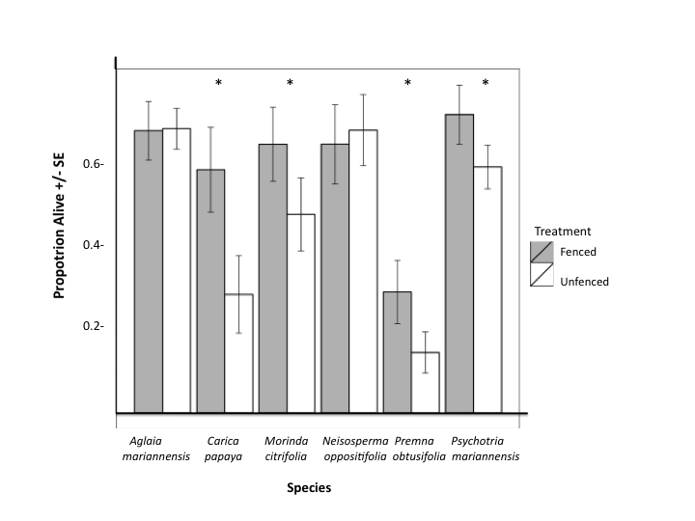

**Figure 1.** Survival in seedling plots with and without feral ungulates. Error bars show one standard error of the mean. Effect on seedling survival based on model selection between models with and without treatment.

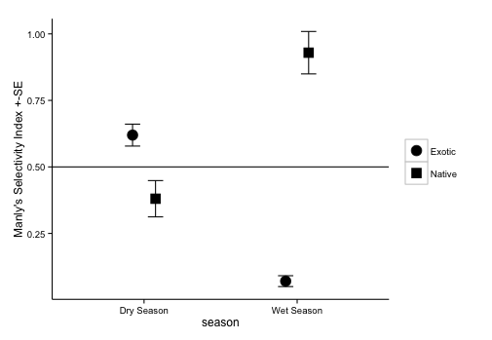

**Figure 2.** Manly Selectivity Index values (*B*) for native and exotic plants during rainy and dry season. Error bars indicate standard error defined for selectivity in Manly 1993.

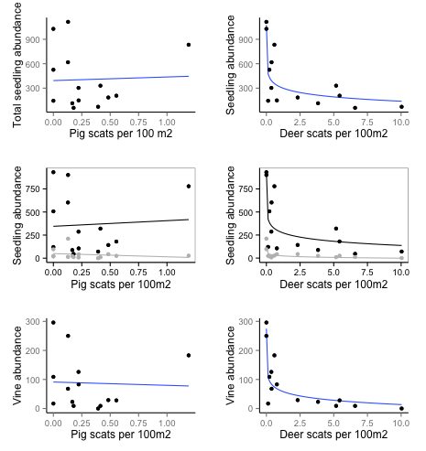

**Figure 3.** Correlation between a suite of forest community characteristics and pig abundance, as estimated by pig scats. Total seedling abundance related to deer abundance, r2=0.710 with P<0.001; native and exotic seedling abundance, r2=0.647 and r2=0.696, respectively, with P<0.001for each; and vine abundance r2=0.751 with P<0.001.